# MAEG 5720 Computer Vision in Practice

# HW2

XIA, Lei 1155169110

Dr. Terry Chang

26 October 2021

## Problem (1)

### (a)

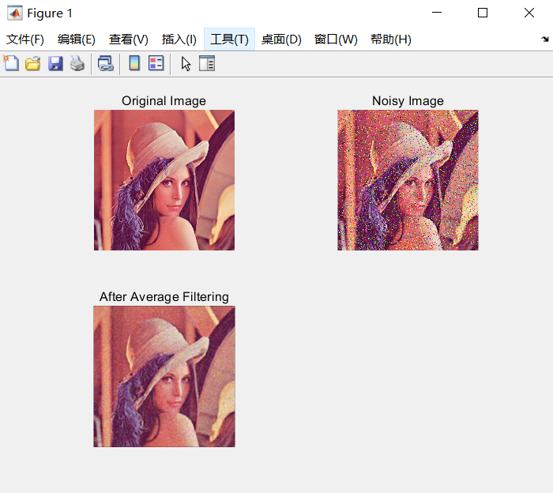

### (b)

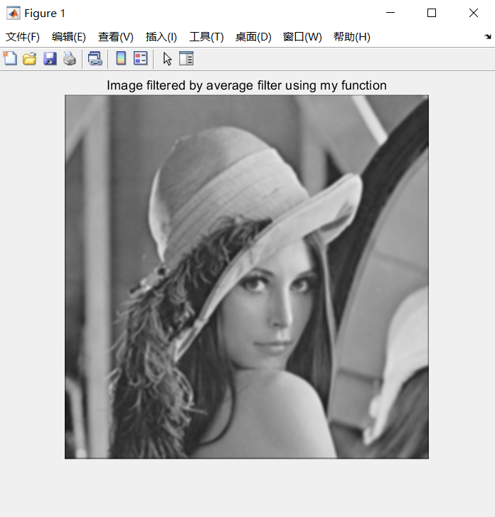

### (c)

Comment: Larger kernel size can make images smoother.

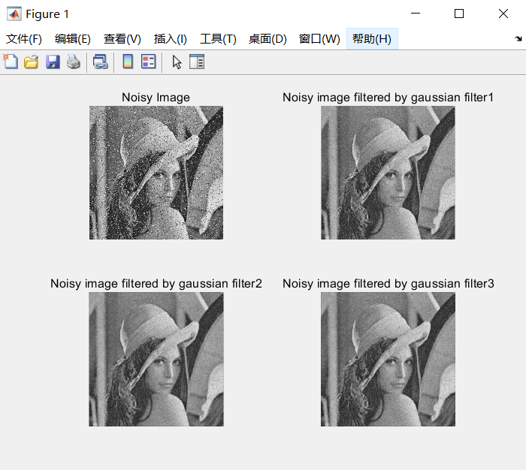

### (d)

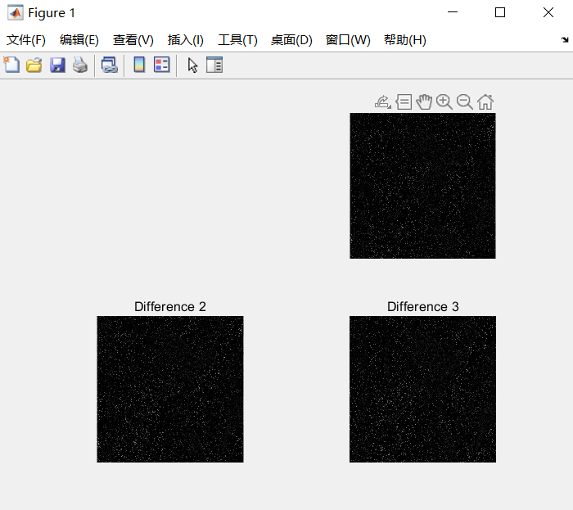

### (e)

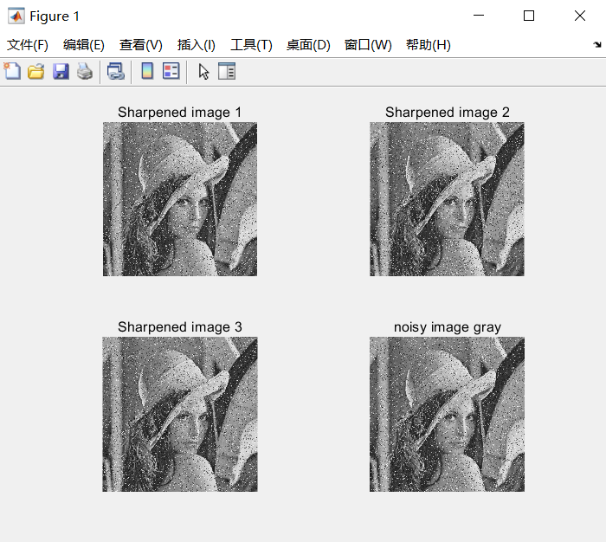

## Problem (2)

### (a)

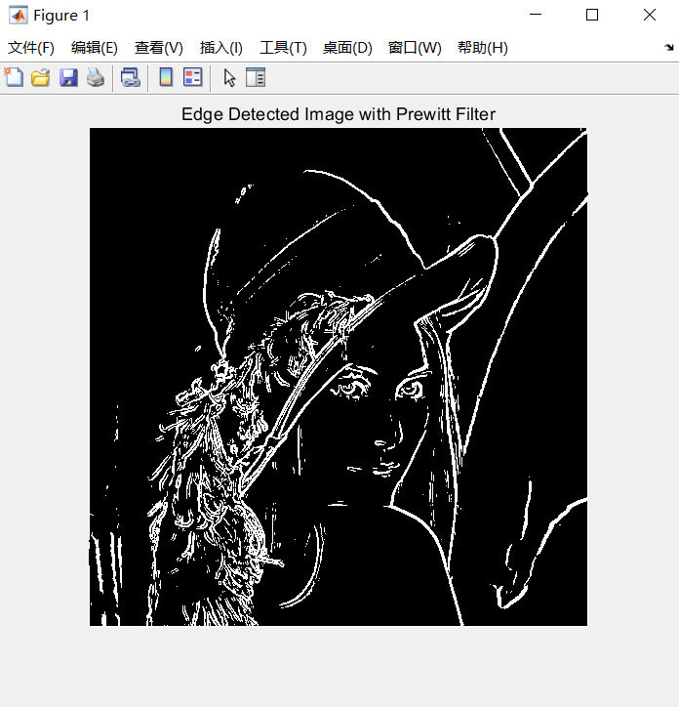

### (b)

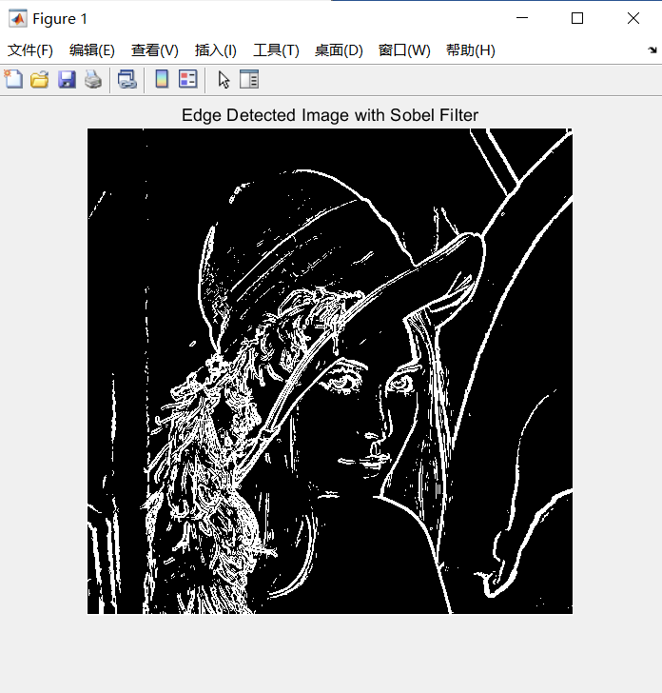

## Problem (3)

### (f)

The following is the picture before double threshold, which is after the process of non-maximum suppression.

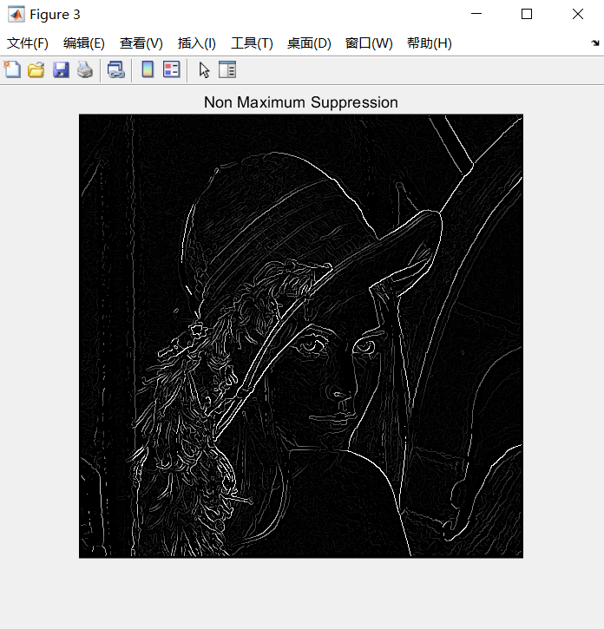

The following picture shows the final result of canny edge detection.

